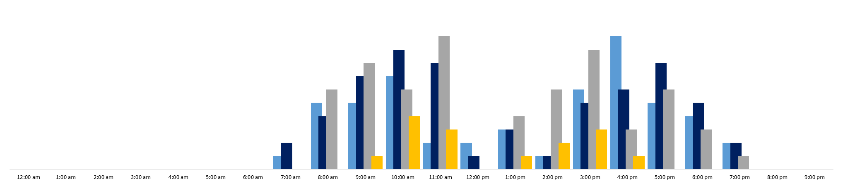
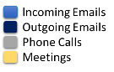
Jonathan W. Jones
1750 North Bayshore Drive
Miami, FL 33131
Phone: 305-209-7753
jonathan.jones@whitehousegov.us
JonathanWJones.com

Jonathan’s Daily Average Productivity
EXPERIENCE
Investment Analyst [Strond Capital] - (Remote, various locations) May 2020 – Present
- Source, analyze and develop a thesis for each newly proposed investments.
- Read and translate data gleaned from 10-K’s, 10-Q’s, 8-K’s, and prospectuses.
- Research and write detailed investment recommendations for shareholders.
- Provide trade settlement data, coordinate the delivery/payment of securities, and answer investor requests.

Operations Analyst/Associate [Kaseya] - (Miami, FL) August 2018 – April 2020
- Analyzed data across multiple Salesforce CRMs to identify Business Development opportunities.
- Resolved issues in the product/service delivery pipeline through systematic process monitoring and analysis.
- Deployed high-level analytics to efficiently and effectively price, manage and staff client engagements.
- Performed data analysis for sales forecasting, pipeline management, executive dashboard creation.

Business Development Data Analyst [Castle Group] – (Plantation, FL) September 2016 – August 2018
- Built budget forecasts, cashflow projections, and investment analyses to manage Condo/HOA revenue.
- Used previously untapped data to help the company streamline operations and garner new customers.
- Collected, analyzed, and delivered relevant consumer data to the CEO, CFO, COO, and company Vice Presidents.
- Conducted market trend analyses that influenced corporate strategy and made budgetary recommendations.

Data Analyst II [Florida International University] - (Miami, FL) May 2014 – September 2016
- Proactively identified marketing and enrollment trends to capitalize on student buying behaviors.
- Planned and executed data collection projects targeted to the University populace.
- Created and reported on key metrics to measure and improve revenue-generating operations and enrollment.
- Provided quantitative reports to executives in Excel/Tableau, delivering actionable intelligence to decision-makers.

Pricing Analyst/Treasury Analyst [CORESTAFF Services] - (Atlanta, GA) October 2012 – April 2014
- Analyzed and developed strategic labor pricing for new, current, and prospective clients.
- Forecasted, monitored and tracked cash flow to manage and reconcile daily cash application and disbursements.
- Received and processed incoming/outgoing wire transfers of company assets up to $25 million.

Commodity Broker [Statewide FX, Inc] - (Los Angeles, CA) February 2009 – Jan 2010
- Earned a Series 3 License to trade commodities on the Chicago Mercantile Exchange.
- Garnered 374 new clients and developed company’s customer retention strategy.
- Served as the youngest federally-licensed broker in the firm’s history.

EDUCATION

Bachelors of Science - Marketing Rutgers University
International Politics – Study Abroad Program University of Oxford, via NYU
Masters of Public Policy Program UCLA
Graduate-level Statistics & Economics MOOC courses M.I.T.

SKILLS

Tableau Desktop
Data Visualization
Microsoft Excel
Data Analysis
Registered Economist
The American Economic Association
Financial Analysis
Microsoft Office
Pricing Strategy
Market/Pricing Analysis
Marketing Strategy
Relational Databases
Google Analytics
Salesforce.com
Market Research
Social Media Marketing
CRM Databases Strategic Planning

